Jordan Mitchell

1/9/2025

Professor Chan

Assignment: Users and Solutions

**Design and Purpose**

For this assignment, I have chosen to analyze Duolingo, a popular app designed to help users learn languages. Duolingo's primary task is to help users learn languages in a fun and engaging way by gamifying the learning process. The overall goal of the app is to make language learning accessible to all, requiring only an internet connection. The app incorporates various design elements to fulfill that purpose. Characters like Vikram and Junior consistently appear throughout lessons and stories, creating an interactive experience. Multiple methods of teaching like reading, listening, and speaking, not only cater to different learning styles but also improve retention and fluency through practical use. Additionally, bright, engaging visuals and animations motivate users, while features like the ranking system and progress path encourage regular practice.

**User Needs Addressed**

Duolingo addresses the needs and interests of users who want to learn new languages and now, even math or music. The app fulfills these needs by offering a structured way to learn languages, consistent practice opportunities, and engaging features that motivate users to keep progressing. Daily lessons build upon previous ones, gradually increasing in difficulty to strengthen skills and enhance fluency. The app’s layout is designed like a path, with each lesson "leading" users closer to their goal of language fluency. To further support users, Duolingo has features like push notifications and widgets to remind them to practice or maintain their streaks. The widgets have creative visuals depicting the Duolingo owl mascot, which reflect user progress. For example, flames for streaks or a cold owl for streak freezes. The app also provides XP charts, badges, and leaderboards which encourage users to take action and practice often. Positive reinforcement is another core feature, with animations celebrating consecutive correct answers. Additionally, users can complete up to 3 daily missions to earn gems and prizes, culminating in a monthly badge for completing at least 30 missions in a month. These features address user needs while encouraging action through rewards and social features. Users can compete with friends on leaderboards or track each other’s progress. These gamified aspects, combined with regular reminders and community engagement, make learning fun while maintaining focus on the user’s goals.

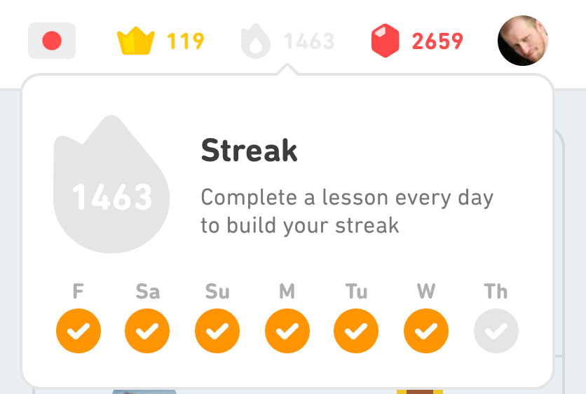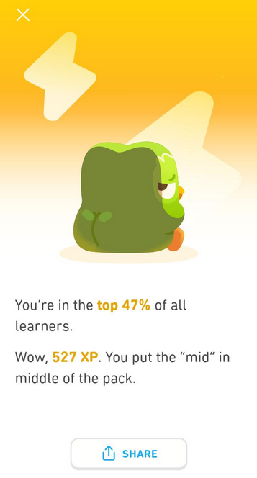

**Specific Features**

Duolingo offers a variety of features designed to meet any learning needs. Compact lessons progressively build on previous concepts, using multiple methods like reading, listening, and speaking to build fluency and confidence. The app’s gamified elements such as XP rewards, streaks, leaderboards, and prizes for completing daily and monthly goals encourage everyday use and make learning enjoyable with a reward system. Positive reinforcement in the celebratory animations further motivates users to stay engaged. Additional features include push notifications and widgets with the owl mascot to remind users to practice, while premium tiers like Duolingo Super and MAX provide ad-free experiences, AI-driven explanations, and conversational practice. Social elements like the leaderboards and progress tracking with friends, create a sense of community that can help users keep each other accountable. Combined with a path shaped layout and vibrant visuals, Duolingo is user friendly and effective.



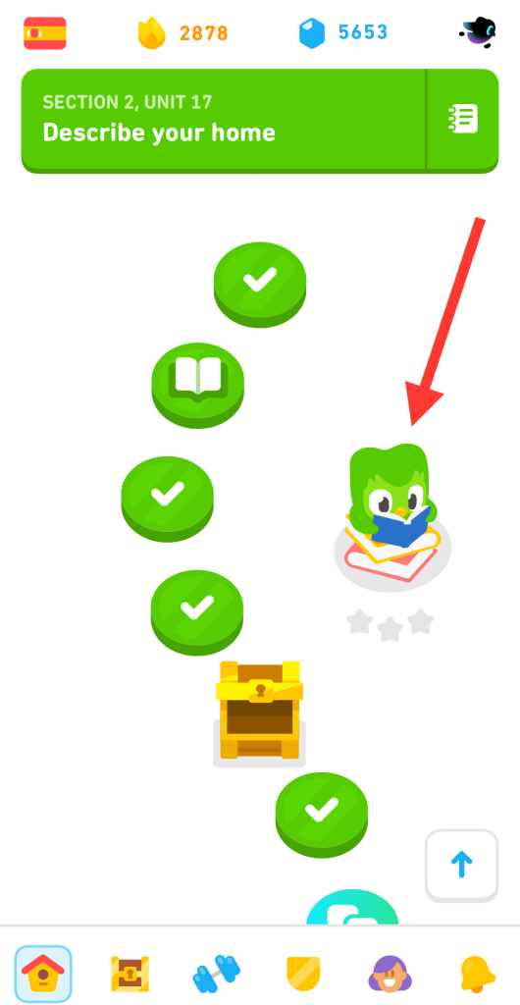

**User Information Developers Need**

For Duolingo to improve its offerings and retain users, developers rely on data to understand user behavior, preferences, and challenges. Key information includes demographics like age, native language, and preferred learning language, as well as learning goals (casual learning or advanced fluency). Usage patterns such as lesson completion rates and time spent on the app, help developers improve features and refine engagement strategies. Feedback on pain points is especially valuable, as it emphasizes where users struggle or disconnect. For example, understanding which lesson styles users find too difficult can lead to improved design or better difficulty scaling. Developers can also track how users interact with features like streaks and leaderboards to identify ways to retain and motivate customers.

I believe they can improve by reintroducing the community comment section, which previously allowed users to discuss specific lessons and words. Fluent local speakers often provided valuable context and authentic insights into the nuances of their respective language. Restoring this feature could strengthen the community and offer users an additional resource for clarifying doubts. I personally remember a specific commenter who regularly gave me helpful feedback and ways to improve beyond what the app had shown. By collecting and analyzing this information, Duolingo can continue to innovate and provide the most effective learning experience.